JAVA FOUNDATIONS :

PRACTICES – SECTION 6

Problem 1: validate a bank pin

PROGRAM :-

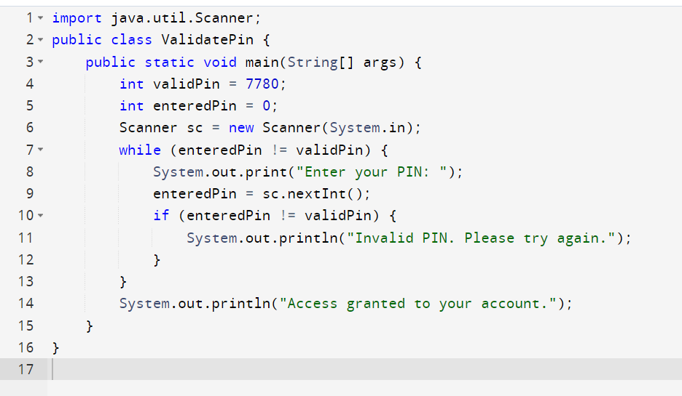

OUTPUT :-

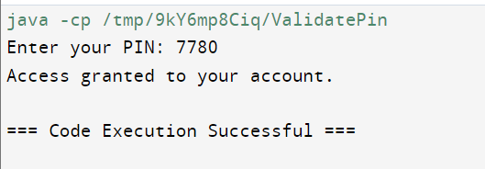

PROBLEM 2: DISPLAYING MULTIPLES OF A NUMBER

PROGRAM :-

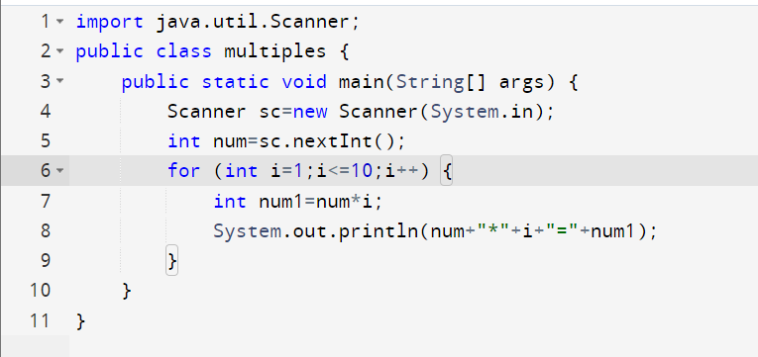

OUTPUT :-

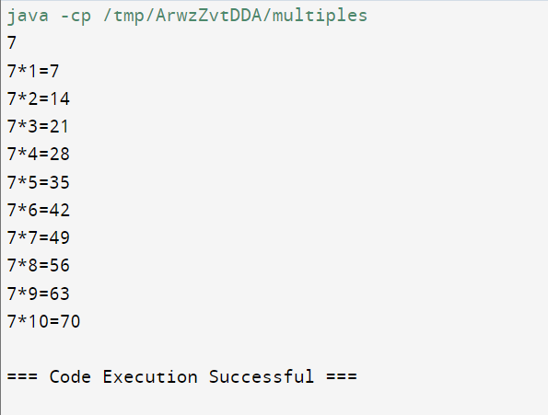

PROGRAM 3 :- Programmatic ASCII Art

PROGRAM :-

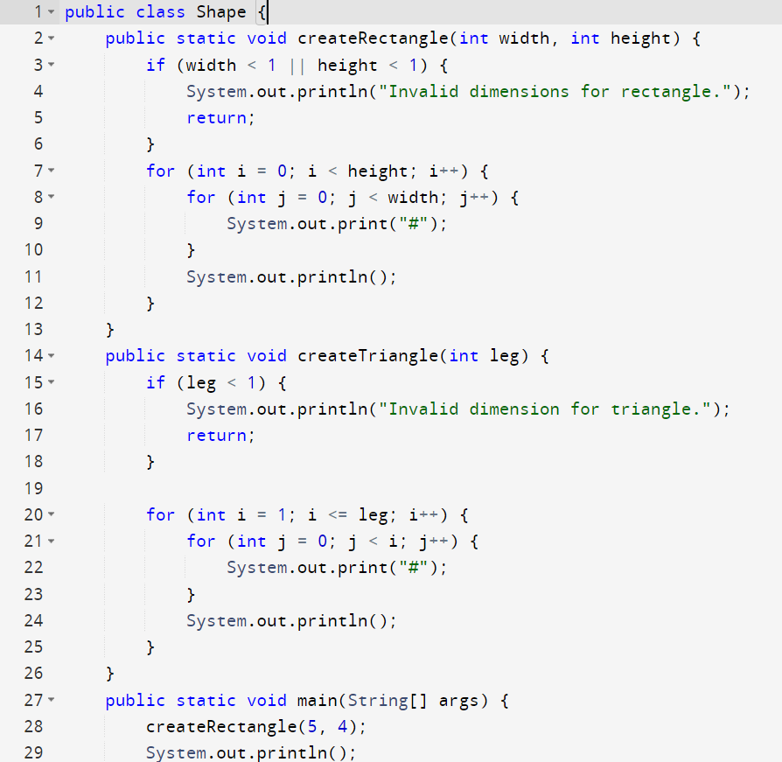

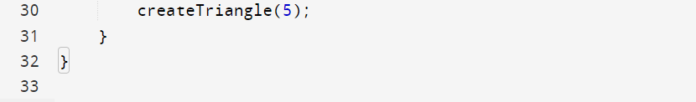

OUTPUT :-

